Cloud networking.
Overview of Virtual Network
Filter Network Traffic – NSG
Secure Network Traffic
Application Security Groups
Difference between NSG and ASG
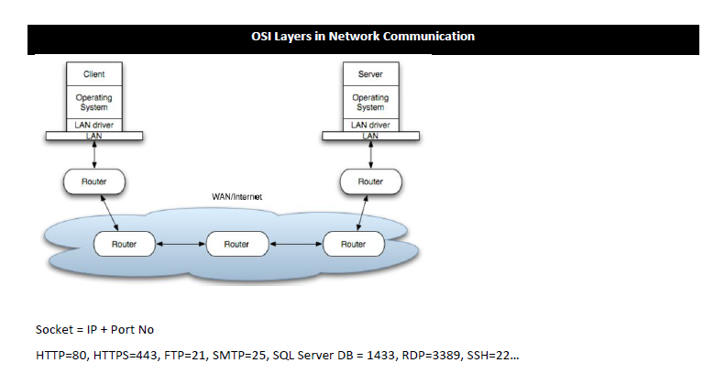
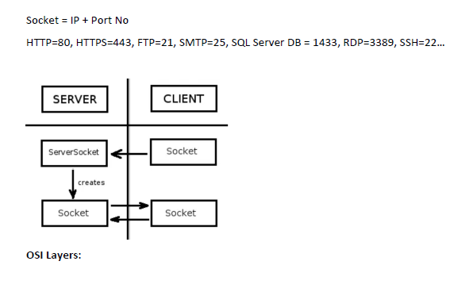
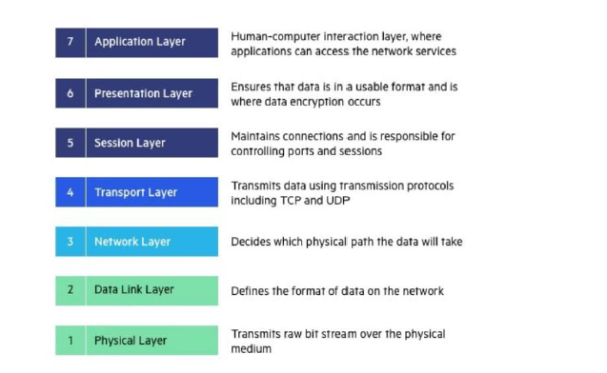

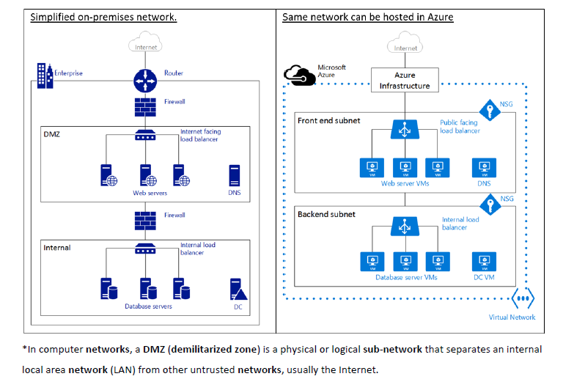
Scenario | DNS Role
Hosting a website | Public DNS zone maps domain to Azure Web App
Internal service discovery | Private DNS zone resolves VM names in a VNet
Hybrid cloud | DNS integrates with on-premises and Azure resources
Load balancing | DNS works with Traffic Manager to direct traffic

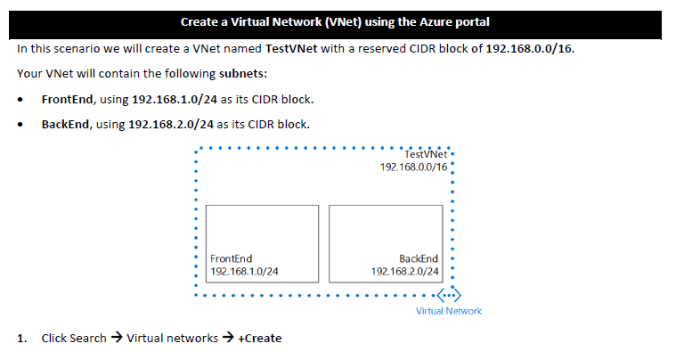
Here’s a complete step-by-step + concept guide for:
- Virtual Network (VNet)
- Network Security Group (NSG)
- Securing Network Traffic
- Application Security Groups (ASG)
- NSG vs ASG (important interview topic)
All explained with What, Why, When, Where + Azure Portal steps

1. Virtual Network (VNet)

What
A Virtual Network is a private network in Microsoft Azure where your resources communicate securely.

Why
- Isolate resources
- Secure communication
- Control IP addressing

When to Use
- Hosting VMs
- Microservices architecture
- Secure backend communication

Step-by-Step (Azure Portal)

Step 1: Open Portal
Go to: Microsoft Azure Portal

Step 2: Create VNet
- Search → Virtual Networks
- Click Create

Step 3: Basics
- Resource Group → MyNetworkRG
- Name → MyVNet
- Region → Central India

Step 4: IP Addresses
- Address space → 10.0.0.0/16
- Subnet →
  - Name → Subnet1
  - Range → 10.0.0.0/24

Step 5: Review + Create → Create

Notes
- VNet = like your office network
- Subnet = department inside network

2. Network Security Group (NSG)

What
A firewall to allow/deny traffic

Why
- Protect VMs
- Control inbound/outbound traffic
Note:-
Inbound and outbound traffic in an Azure Virtual Network (VNet) refers to how data flows into and out of resources (like VMs, databases, or apps) inside that network. Understanding this is key to designing secure and efficient cloud architectures.

Inbound Traffic
Inbound traffic is data entering your VNet from external sources:
- From the internet: e.g., a user accessing a web app hosted in Azure.
- From other VNets or on-premises networks: via VPN Gateway or ExpressRoute.
- Controlled by Network Security Groups (NSGs), Azure Firewall, or Application Gateway.
- Example: Allowing inbound TCP port 443 (HTTPS) to a web server VM.

Outbound Traffic
Outbound traffic is data leaving your VNet to external destinations:
- To the internet: e.g., a VM downloading updates or connecting to an API.
- To other VNets or on-premises networks: for hybrid connectivity.
- Controlled by NSGs, firewalls, and routing rules.
- Example: Restricting outbound traffic so only specific IP ranges or services are reachable.

How Azure Manages It
- NSGs (Network Security Groups): Define inbound/outbound rules at subnet or NIC level.
- User-Defined Routes (UDRs): Control outbound traffic paths (e.g., force traffic through a firewall).
- Azure Firewall / NVA (Network Virtual Appliance): Provide centralized outbound filtering and logging.
- Load Balancers: Manage inbound traffic distribution across multiple VMs.

Quick Comparison
Aspect | Inbound Traffic | Outbound Traffic
Direction | Into VNet | Out of VNet
Common Sources | Internet, other VNets, on-premises | Internet, other VNets, on-premises
Control Mechanisms | NSGs, Application Gateway, Load Balancer | NSGs, UDRs, Azure Firewall
Example | User accessing web app | VM calling external API

Since you currently have the Azure Portal open on your VNet page, you can check inbound/outbound rules by navigating to: Azure Portal → Your VNet → Subnets → NSG → Inbound/Outbound Security Rules.

When
- Always use with VM
- Secure APIs, databases

Step-by-Step (Azure Portal)

Step 1: Create NSG
- Search → Network Security Groups
- Click Create

Step 2: Basics
- Name → MyNSG
- Resource Group → MyNetworkRG
Click Create

Step 3: Add Rule
- Open NSG → Inbound security rules
- Click Add
Example: Allow HTTP
- Source → Any
- Source Port → *
- Destination → Any
- Destination Port → 80
- Protocol → TCP
- Action → Allow
- Priority → 1000
- Name → Allow-HTTP
Click Add

Example Rules
Rule | Port | Use
RDP | 3389 | Windows access
SSH | 22 | Linux access
HTTP | 80 | Web apps
HTTPS | 443 | Secure web

3. Secure Network Traffic

What
Protect communication between resources

How to Secure

Use NSG Rules
- Allow only required ports

Use Private IP
- Avoid public exposure

Use Bastion (optional)
- Secure VM access without public IP

Use Subnets
- Separate frontend & backend

Real Example
Frontend VM → Subnet1
Backend API → Subnet2
Database → Subnet3

NSG Rules:
- Allow Frontend → Backend
- Block Internet → Database

4. Application Security Groups (ASG)

What
Logical grouping of VMs

Why
- Simplify NSG rules
- Avoid using IP addresses

When
- Multiple VMs
- Microservices

Step-by-Step (Azure Portal)

Step 1: Create ASG
- Search → Application Security Groups
- Click Create

Step 2: Basics
- Name → WebASG
- Resource Group → MyNetworkRG
Click Create

Step 3: Assign ASG to VM
- Go to Virtual Machine
- Click Networking → Network Interface
- Click Application Security Groups
- Add → WebASG

Step 4: Use ASG in NSG Rule
- Go to NSG → Inbound rules → Add
Instead of IP:
- Source → Any
- Destination → Application Security Group → WebASG
- Port → 80
- Action → Allow

Benefit
No need to manage IPs manually

5. NSG vs ASG (VERY IMPORTANT)
Feature | NSG | ASG
Type | Firewall | Logical Group
Purpose | Control traffic | Group VMs
Works On | Subnet/NIC | Used inside NSG
Uses IP | Yes | No

Simple Understanding
- NSG = Security Guard 🚔
- ASG = Team/Group 👥

6. Real-World Architecture
Internet
↓
Load Balancer
↓
Frontend VMs (WebASG)
↓
Backend API (ApiASG)
↓
Database (DB subnet - blocked)

7. Interview Notes ( Must Know)

Best Practices
- Never open all ports (0-65535 )
- Use least privilege access
- Use ASG for large systems
- Use separate subnets

Common Questions
Q: Why ASG over IP-based rules?
Easier to manage, scalable
Q: Can NSG work without ASG?
Yes
Q: Can ASG work without NSG?
No

